For more information,
please contact:

Andy Kerr
Director of Product Marketing & Communication
+44 (0) 7590 735140
andy.kerr@soundunited.com

Nicoll Public Relations
Lucette Nicoll or John Nicoll
Lucette@nicollpr.com
781-789-6000
John@nicollpr.com
617-470-9906
Download high-resolution images, fact sheets, and press release from the Bowers & Wilkins Hub.
Bowers & Wilkins announces new
16-channel distribution amplifier.

New CDA-16 distribution power amplifier can power up to eight individual rooms in your home
with high-quality stereo sound, all from one elegant, compact component.

WORTHING, UK (April 1, 2021)—Bowers & Wilkins, the leading global premium audio brand, is proud to announce an exciting new addition to its Custom Installation product portfolio for whole-home audio.
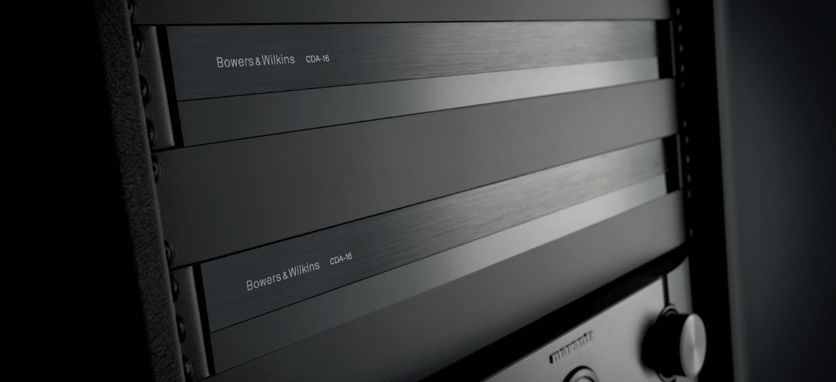

Available April 1, the new Bowers & Wilkins CDA-16 has been engineered to work with any existing Bowers & Wilkins custom installation speaker. With the ability to drive 16 channels or 8 stereo zones, the CDA-16 gives you the maximum performance with the minimum rack space thanks to its compact 1U design. Its configurable specification also allows users to bridge its Class D stereo amplifier channels to create even more powerful mono outputs, if required.

As standard, CDA-16 offers 50W to each of its 16 channels in to 8ohm loads, rising to 100W with 4ohm speakers. Select the bridging function, and that rises to a mighty 200W into 8ohms, ensuring ample control and authority whatever the installation requirements. Connecting sources is simplicity itself, with eight pairs of RCA phono inputs for line-level analogue connection with the option of using one set of inputs as a ‘global’ connection that shares the same signal across all outputs.

Suitable for rack-mounting, the ultra-compact CDA-16 uses cool-running Class D amplification to ensure maximum power output coupled to impressive energy efficiency. At just 44.5mm high, it’s
easily accommodated in both hi-fi and installation rack systems.

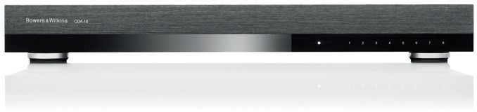
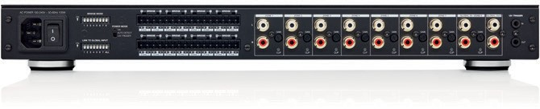

CDA-16 key features:

- 16 x 100w into 4ohms giving eight stereo zones, or 8 x 200w in 8ohms in bridged mode.
- Eight RCA analog inputs for stereo sources per zone, plus the option of a global source for all zones.
- Three power mode options for control – on, auto-source detect and 12v trigger.
- Robust, reliable protection features to prevent damage due to overload, short-circuit or heat.
- Ultra-compact 1U rack-mount design for easy installation and configuration.

Available April 1st 2021.

$1,999.99 USD

For more information about the new CDA-16, please visit bowerswilkins.com.

About Bowers & Wilkins
Bowers & Wilkins, founded in the U.K. in 1966, has been at the forefront of high-performance audio technology for more than 50 years. It designs and manufactures precision home speakers, headphones, custom installation and performance car audio products that set new standards for innovation and sound quality, earning countless awards and accolades from the world’s leading recording studios and musicians. Bowers & Wilkins’ reputation is based on the unwavering pursuit of the best possible sound and an unsurpassable music listening experience. Bowers & Wilkins joined the Sound United LLC family of brands in 2020. Learn more at www.bowerswilkins.com.

