BMW iX x Bowers & Wilkins

THIS INFORMATION IS EMBARGOED UNTIL 7th SEPTEMBER 2021--noon EST

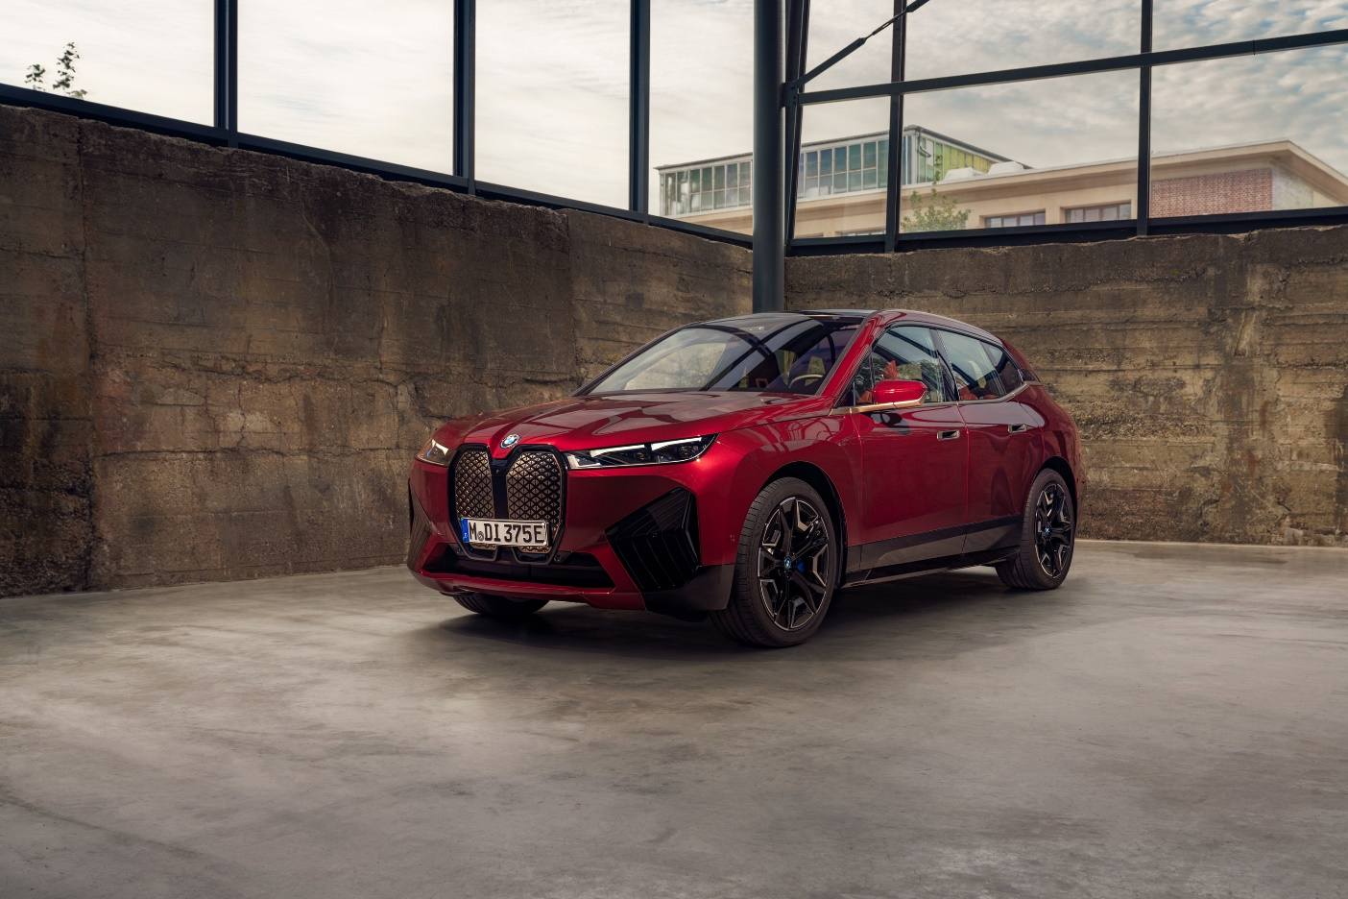
Bowers & Wilkins, the British loudspeaker company famed for bringing its knowledge and experience of acoustic excellence to the automotive industry, has extended its successful partnership with BMW, with the launch of the iX, the new luxury electric SAV from BMW.

The Bowers & Wilkins Diamond Surround Sound System in the iX features the most advanced sound quality found in a car, with the aim of delivering an audio experience that feels as though you are there with the artist in the studio, a concept that Bowers & Wilkins refer to as ‘True Sound’. This can only be achieved through close collaboration between the engineering teams from both BMW and Bowers & Wilkins, and by using proven technologies from Bowers & Wilkins’ core range of passive loudspeakers.

The BMW iX is the first fully electric vehicle to feature Diamond Dome tweeters, as found in Bowers & Wilkins 800 Series Diamond loudspeakers, the monitor loudspeaker of choice in Abbey Road Studios. The exceptionally accurate, low-distortion tweeters feature Nautilus™ swirls, spiralling channels behind the tweeter domes that dissipate reflected sound waves that emanate from the rear of the drive unit and limit distortion. In keeping with the minimalist interior of the BMW iX, the tweeters are covered with brushed stainless-steel covers with a laser-etched logo and a discreet lighting effect, and the door speakers are discretely hidden behind acoustically optimized fabric.
In total, there are two Diamond Dome tweeters, three Aluminium Dome tweeters and five Aramid Fibre midrange speakers mounted as high as possible within the light, spacious cabin. A further eight speakers are integrated into the front and rear headrests, which can be individually adjusted to create a truly personalised audio experience for each passenger. For the first time, four bass speakers are joined by 4D Shakers that are strategically positioned within the interior to produce a rich bass experience even at low volumes.
Passengers can engage with the sound system through four different sound modes, according to preference.

The result is sound that’s superbly detailed and free from coloration, seamlessly integrated within the car design.

For additional information on Bowers & Wilkins, please visit www.Bowerswilkins.com

For more information, please contact: Andy Kerr Director of Product Marketing & Communication +44 (0) 7590 735140 andy.kerr@bowerswilkins.com or, Lucette Nicoll: lucette@nicollpr.com, or John Nicoll: john@nicollpr.com

Download high-resolution images, fact sheets, and press release from the Bowers & Wilkins Hub The content in this news release is accurate at the time of publication but may be subject to change without notice. All trademarks mentioned in this news release are the property of their respective owners. Copyright © B&W Group Ltd. E&O

