THIS INFORMATION IS CONFIDENTIAL UNTIL SEPTEMBER 2nd 2020

For the love of music – iconic 600

Series celebrates 25 years of success with new Anniversary Edition range.
N. Reading, MA – August 25, 2020: 25 years of continuous success, six generations of engineering excellence and more than a million products sold – these are milestones worth celebrating!
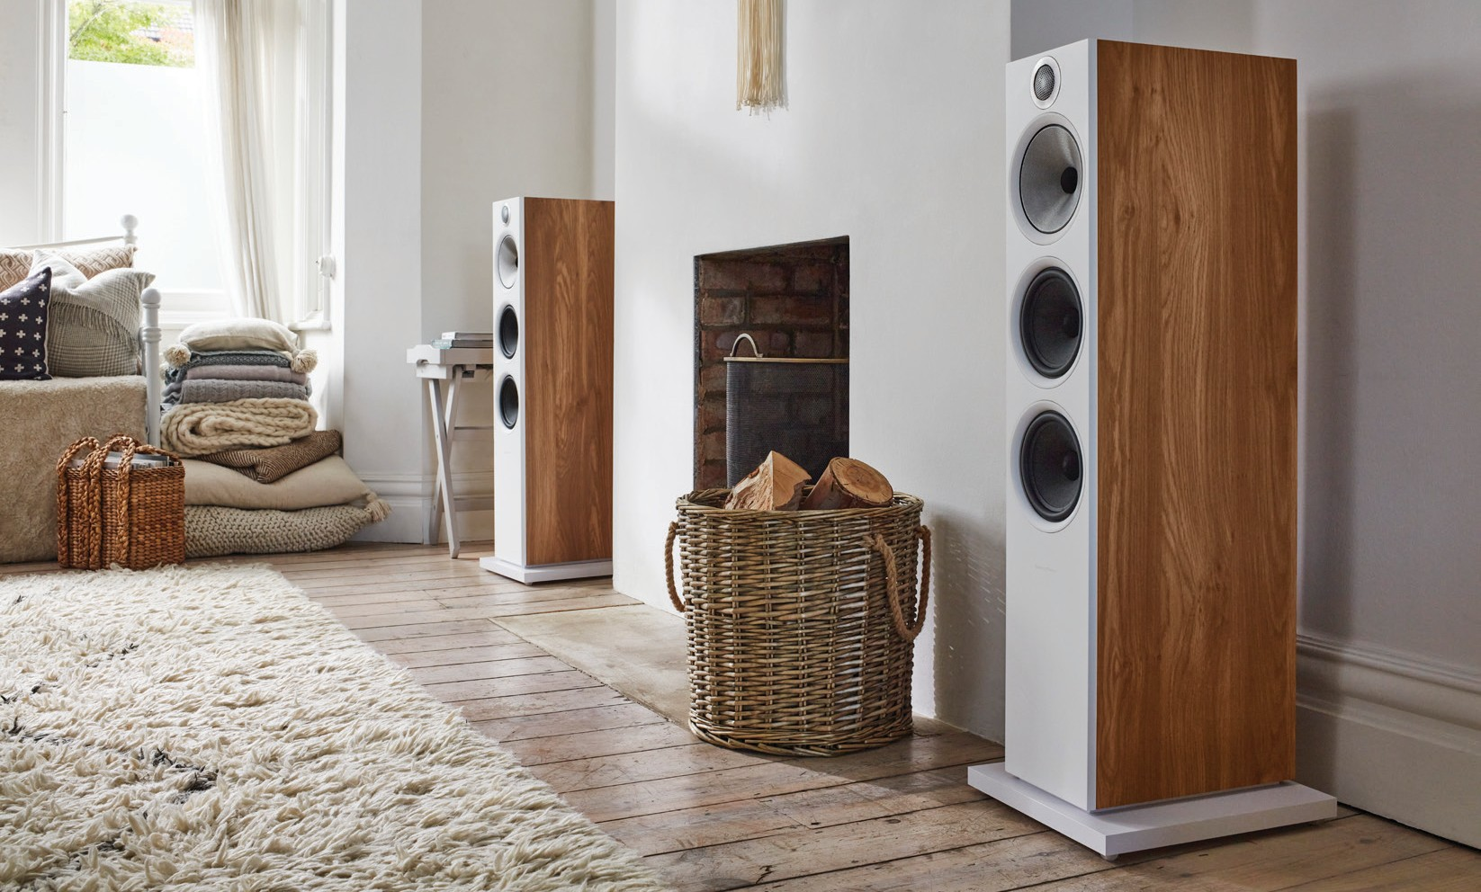

This month sees the launch of the new 600 Series Anniversary Edition, the seventh generation of 600 Series loudspeakers from Bowers & Wilkins. The new range shares the same blend of outstanding value and superlative sound quality as its six forebears but, in Bowers & Wilkins’ tradition, features new and improved components to ensure it can continue to set the standard for high-performance sound quality at
an accessible price point.

For 25 years, the 600 Series has been the music lover’s affordable introduction to the Bowers & Wilkins family of audiophile loudspeakers. The new range is the company’s second-longest continuously available series after the legendary 800 Series Diamond.

Bowers & Wilkins has always been unique in developing and manufacturing all key components in-house and in passing those technologies down between ranges over time. This policy has consistently allowed 600 Series models to offer better quality components and technologies than any comparable competitor, enabling sound quality rivalling that of far more expensive speakers.

The new 600 Series Anniversary Edition range has followed this same path by offering significant component improvements over the sixth version of the 600 Series, itself introduced in 2018. The 600 Series Anniversary Edition range features four models that combine advanced technology with discreet style, adding a new oak finish to complement the existing matte black or matte white finishes. An additional red cherry finish is available as a special order. All Anniversary Edition speakers also include a new celebratory logo inscribed on the tweeter surround in either light or dark finishes, depending on the color of the rest of the speaker.

The new range includes ‘S2’ specification Anniversary Edition versions of the 607, 606, 603 and the dedicated HTM6 centre channel speaker, while the existing ASW608, ASW610 & ASW610XP subwoofers plus the STAV24 S2 speaker stand continue unchanged. There’s also 600 Series Anniversary Edition Theatre home cinema package, based on the 603 S2, 607 S2 and HTM6 S2 Anniversary Edition speakers, partnered by the ASW610 subwoofer.

Acoustic performance upgrades come from upgraded crossovers in every model. New and greatly improved bypass capacitors are used across the new Anniversary Series: these have been specially treated by Mundorf and were originally used for the recently launched 700 Series Signature range.

In addition, the main high-frequency and mid-frequency capacitors have been upgraded with new, improved designs. The result is greatly improved resolution and transparency across all of the 600 Series Anniversary Edition speakers.

“The 600 Series Anniversary Edition is a classic example of Bowers & Wilkins thinking” said Andy Kerr, Director of Product Marketing & Communications. “By using our unique, in-house-developed components and technology from higher ranges, we can raise the performance of our entry-level product to new heights and for a very modest premium. The 600 Series has been setting the standard in its category for 25 years and we’re confident our new Anniversary Edition range will carry on that tradition in style.”

The line-up includes:

603 S2 Anniversary Edition – $1,999.98 / per pair (USD)
A floorstanding speaker delivering outstanding power, scale, accuracy and musicality. Featuring the Decoupled Double Dome aluminum tweeter, a 150mm (6”) FST Continuum Cone midrange driver plus two 165mm (6.5”) paper-cone bass drivers.

606 S2 Anniversary Edition – $899.98 / per pair (USD)
Suitable for stand-mount or bookshelf use, this compact speaker delivers stunning resolution and tonal neutrality with outstanding bass extension. Combines the Decoupled Double Dome aluminum tweeter technology with a 165mm (6.5”) Continuum Cone mid/bass driver.

607 S2 Anniversary Edition – $699.98 / per pair (USD)
Compact stand-mount or bookshelf speaker offering outstanding bass response and insight from its main 130mm (5”) Continuum Cone mid/bass driver.

HTM6 S2 Anniversary Edition – $799.99 each (USD)
A compact high-performance centre-channel speaker with considerable power and exceptional resolution and precision. Featuring the Decoupled Double Dome tweeter plus dual 130mm (5”) Continuum Cone mid/bass drivers.

STAV24 S2 floorstand – $199.98 per pair (USD)
24in stand suitable for use with both 607 S2 and 606 S2 Anniversary Edition

ASW608, ASW610 and ASW610XP – $499.99 / $799.99 / $1,499.99 (USD)
Completing the range are three exceptional subwoofers carried over unchanged from the sixth generation 600 Series. Available in matte black or matte white.

600 Series Anniversary Edition Theatre – $4,299.94 (USD)
Notes to editors

For more information, please contact:

Lucette Nicoll or
John Nicoll

Nicoll Public Relations
781-789-6000
617-470-9906
lucette@nicollpr.com
john@nicollpr.com

Download high-resolution images, fact sheets, and press release from the Bowers & Wilkins Hub here.

5.1 speaker package featuring 603 S2, 607 S2, HTM6 S2 Anniversary Edition plus the ASW610 active subwoofer.

For more information about the new 600 Series Anniversary Edition, please visit bowerswilkins.com.

About Bowers & Wilkins
Bowers & Wilkins, founded in the UK in 1966, has been at the forefront of high-performance audio for more than 50 years. Bowers & Wilkins designs and manufactures precision home speakers, headphones, custom installation and performance car audio products that set new standards for innovation and sound quality, earning countless awards and accolades from the world’s leading recording studios and musicians. Bowers & Wilkins’ reputation is based on the unwavering pursuit of the best possible sound and an unsurpassable music listening experience. Learn more at bowerswilkins.com.

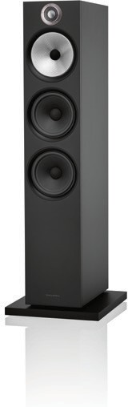
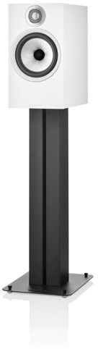
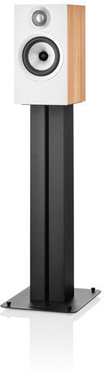
Director of Product Marketing & Communication
+44 (0) 7590 735140
andy.kerr@bowerswilkins.com

Andrew Burslem
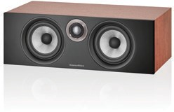
CMC P

Continuum is a trademark
of B&W Group Ltd. Mundorf
is a trademark of Mundorf
EB GmbH.

